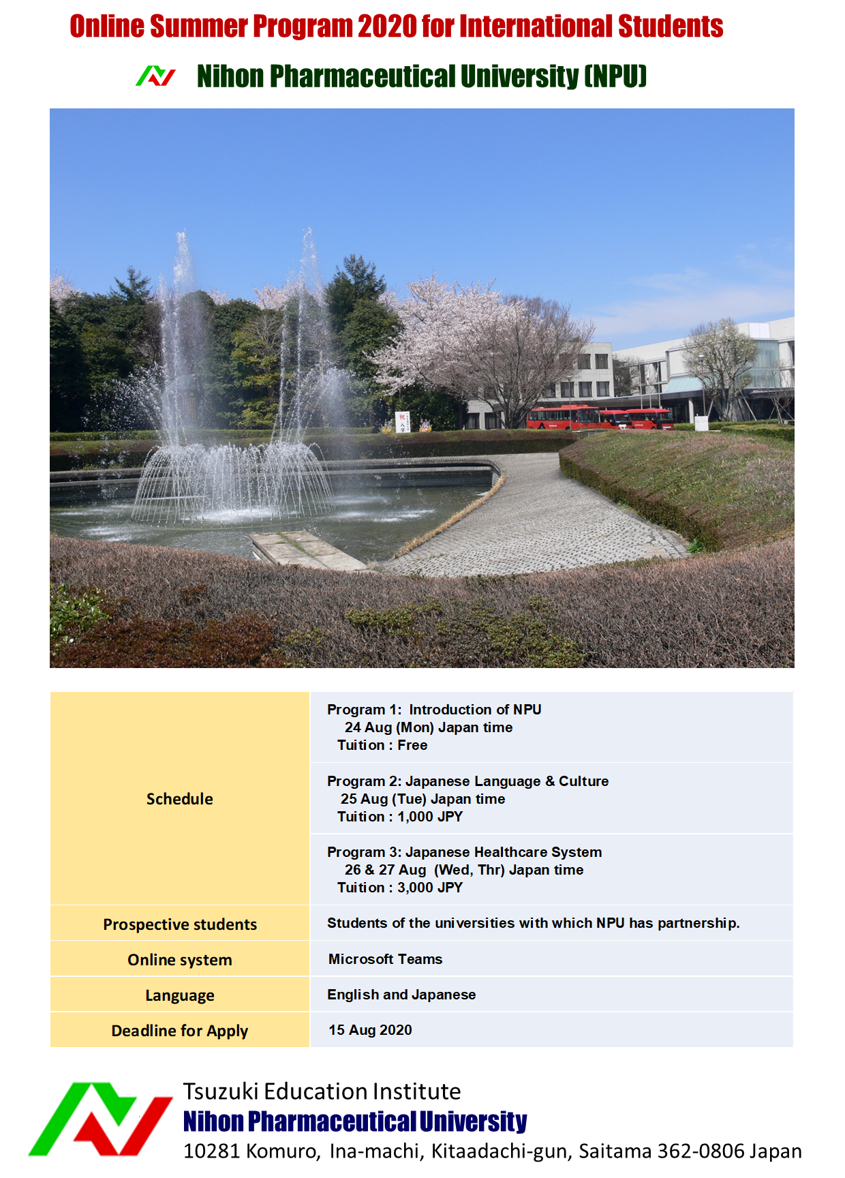

**IMPORTANT**

Microsoft Teams is used for this program.

To view this program, you must download Microsoft Teams on your PC, tablet, or smartphone.

The invitation for this program will be sent to your e-mail address.

Make sure that e-mail address you apply for this program is one that can be used on the device where you downloaded Microsoft Teams

To Students of the universities with which NPU has partnerships

In previous years, NPU has hosted a summer program with students from our partner schools. However, this year, due to the problem of the new coronavirus infection, we cannot invite you to Japan. Therefore, we have decided to hold the summer program online instead. If you are interested, please contact us and enjoy our programs.

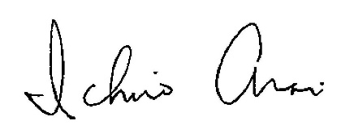

Ichiro ARAI, PhD, Prof

Chair of International Exchange Committee

Nihon Pharmaceutical University, JAPAN

Program 1: Introduction of NPU

24 Aug (Mon) Japan time

Tuition : Free

|  |  |  |
| --- | --- | --- |
| Japan Time | UTC |  |
| 10:00-11:00 | 01:00-02:00,  24 AUG | Introduction 1 Introduction of NPU |
| 11:10-11:30 | 2:10-2:30,  24 AUG | Visit 1 NPU tour（Saitama Campus） |
| 11:40-12:40 | 02:40-03:15,  24 AUG | Introduction 2 Previous NPU Summer Program |
| 13:40-14:00 | 04:40-05:00,  24 AUG | Visit 2 NPU tour（Ochanomizu Campus） |
| 14:10-15:10 | 05:10-06:10,  24 AUG | Visit 3 NPU Kampo Museum & herbarium |

The contents of the program are subject to change.

Program 2: Japanese Language & Culture

25 Aug (Tue) Japan time

Tuition : 1,000 JPY

|  |  |  |
| --- | --- | --- |
| Japan Time | UTC |  |
| 10:00-11:00 | 01:00-02:00,  25 AUG | Lecture 1 Japanese Language (1) |
| 11:10-11:30 | 2:10-2:30,  25 AUG | Visit 1 Kimono dressing club of NPU |
| 11:40-12:40 | 02:40-03:15,  25 AUG | Lecture 2 Japanese Language (2) |
| 13:40-14:00 | 04:40-05:00,  25 AUG | Visit 2 Tea ceremony club of NPU |
| 14:10-15:10 | 05:10-06:10,  25 AUG | Lecture 3 Japanese Language (3) |
| 15:20-16:20 | 06:20-07:20,  25 AUG | Lecture 4 Japanese Culture-Recent trend in Japan (Prof. KURIHARA Taiga) |
| 16:30-17:30 | 07:30-08:30,  25 AUG | Lecture 5 Japanese Language (4) |

The contents of the program are subject to change.

Program 3: Japanese Healthcare System

26 & 27 Aug (Wed, Thr) Japan time

Tuition : 3,000 JPY

26 Aug (Wed) Japan time

|  |  |  |
| --- | --- | --- |
| Japan Time | UTC |  |
| 10:00-11:00 | 01:00-02:00,  26&27 AUG | Lecture 1 Pharmaceutical education system in Japan（Prof. MATSUDA Yoshikazu） |
| 11:10-11:30 | 2:10-2:30, 26&27 AUG | Visit 1 NIHONDO Co., Ltd. (Traditional Medicine Counseling Pharmacy) |
| 11:40-12:40 | 02:40-03:15, 26&27 AUG | Lecture 2 Traditional medicine in Japanese Healthcare system （Prof. ARAI Ichiro） |
| 13:40-14:00 | 04:40-05:00, 26&27 AUG | Visit 2 RYUKAKUSAN Co., Ltd. (OTC Pharmaceutical Company) |
| 14:10-15:10 | 05:10-06:10, 26&27 AUG | Lecture 3  Virtual Trip to a Medicinal Plant Garden（Prof. NOGUCHI Hiroshi） |
| 15:20-15:40 | 06:20-06:40, 26&27 AUG | Visit 3 TOHO HOLDINGS Co., Ltd. (Dispensing Pharmacy) |
| 15:50-16:50 | 06:50-07:50, 26&27 AUG | Lecture 4 Overview of Japanese Complementary and Integrated Medicines（Prof. ITOKAZU Nanae） |

The contents of the program are subject to change.

Program 3: Japanese Healthcare System (continue)

27 Aug (Thr) Japan time

|  |  |  |
| --- | --- | --- |
| Japan Time | UTC |  |
| 10:00-11:00 | 01:00-02:00,  26&27 AUG | Lecture 5 Overview of Japanese OTC drug（Prof. ITOKAZU Nanae） |
| 11:10-11:30 | 2:10-2:30, 26&27 AUG | Visit 5 WELCIA YAKKYOKU Co., Ltd. (Drug store) |
| 11:40-12:40 | 02:40-03:15, 26&27 AUG | Lecture 6 Japanese medical care and education (normal medical care and disaster medical care)（Prof KUBOTA Yoko） |
| 13:40-14:00 | 04:40-05:00, 26&27 AUG | Visit 6 WAKABA PHARMACY (Dispensing pharmacy) |
| 14:10-15:10 | 05:10-06:10, 26&27 AUG | Lecture 7 Medical problems in Japan, a longevity country（Prof. MAEDA Tomoji） |
| 15:20-15:40 | 06:20-06:40, 26&27 AUG | Visit 7 YUYAMA Co.,Ltd. (Pharmaceutical dispensing equipment company) |

The contents of the program are subject to change.



https://www.nichiyaku.ac.jp/english/